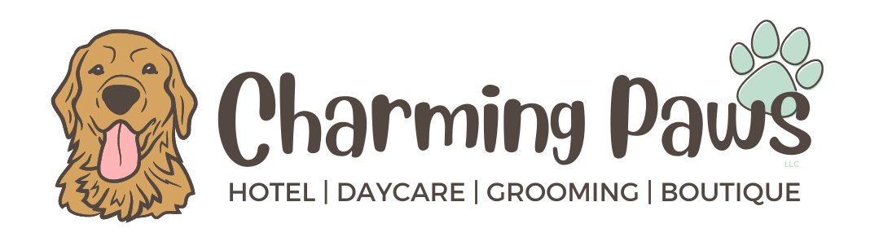

GROOMING MENU

BASIC NEEDS
Hypoallergenic (for sensitive skin) $8.00
Dandruff (helps remove existing dandruff) $8.00
Neem (aids in flea/tick preventative) $8.00
Coat Specific (helps shine and brighten coat with added proteins) $8.00
FOR DRY/ITCHY SKIN
Medicated (soothes dry, itchy, and irritated skin) $8.00
Tea Tree Oil (for dry, sensitive skin) $8.00
Skin Remedy (alleviates skin irritations) $8.00
SEASONAL SHAMPOOS
(softens undercoat to assist in de-shed process, aids in smoother grooming process, prevents matting)
Soft Mimosa & Nectar $12.00
- A romantic aroma combining chamomile, ginseng, rosemary, rose hips and sage extracts.
Harvest Apple $12.00
- True, ripe apple combined with bright fruit notes and a touch of spice. The perfect fall scent for your pup!
Berry Amaretto $12.00
- The tantalizing aroma of Winter berries and amaretto fills the senses with a familiar, festive and comforting experience.
Vanilla Chai Latte $12.00
- Breathe in the aromatic fusion of spicy black chai tea and sweet, warm milk for a scent that feels like you're cozy near the fireplace.
NEW! Senior Dog Package $22.00
- Specifically created with our frosty face friends in mind – our senior dog package will provide your sweet soul with all the necessities for a true pamper session!
  - Includes shampoo, conditioner, fizzy foot soak, bandana, and digital photo of your fur-baby all fresh & clean!
PRICING
(prices are subject to change due to groomer’s discretion)

$60.00 per appointment slot
- Scissoring fees may apply
- De-matting fees may apply
- De-shedding fees may apply
- Special handling fees may apply

A LA CARTE SERVICES

Blueberry Facial Scrub $8.00
Cucumber Melon Facial Scrub $8.00
- Helps soak and gently remove any extra crusted discharge around eye and mouth area and overall, leaves the face smelling delicious!
Deep-Cleansing Fizzy Foot Soak $10.00
- Deep cleans and sanitizes feet and paws
- Helps to eliminate bacteria, fungus, and germs
- Whitens and brightens the nails’ natural color
- Conditions nails
- Softens paw pads
- Replenishes moisture in paw pads
- Helps stop paw licking
Teeth Cleaning $12.00
- Assists in deteriorating plaque build up through the use of enzymatic wipes and helps freshen breath
Nail Grind $8.00
De-Shed Treatment Dependent on breed (ask for quote)
- Extensive de-shed treatment using de-shed shampoo and conditioner, blow-out, and a brush-out

LOOKING FOR SOMETHING ELSE? ASK OUR STAFF!

